- F
- F
- F
- F
- F
- F
- F
- F
- F
- F
- F
- F
- F
- F
- F
- F
- F
- F
- F
- F
- F
- F
- F
- F
- F
- F
- F
- F
- F
- F
- F
- F
- F
- F
- F
- F
- F
- F
- F
- F
- F
- F

----------------------------------------------------------------------------------------------------
- While creating the job or under the configuration tab, there are some options
  - 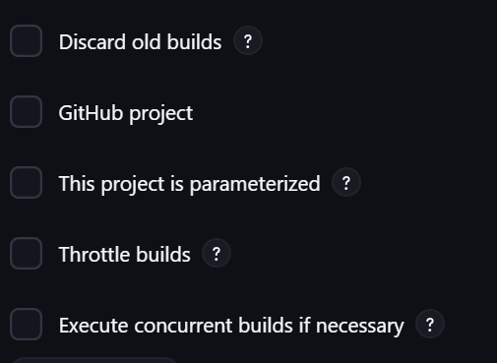
  - This project is parameterized will allow you to set some variables for your job.
- 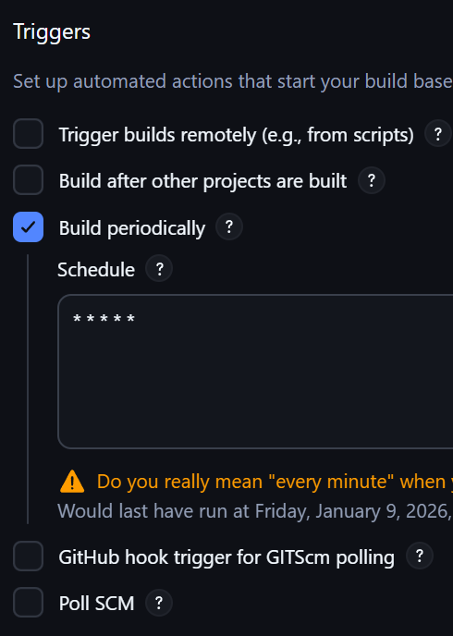
  - Build periodically allow you to write cron-job to build this job automatically in some particular intervals.

- One more thing is there Pole SCM
  - 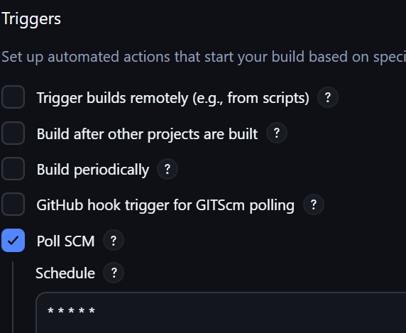
  - I have mentioned the cron for every minute it means it’ll check the github repo every minute and if someone pushes something there then it’ll build.
    - If there is no changes, then it’ll not run the build.
- You can also send email after the build is completed (pass and fail in both the case)
  - We’ll use Gmail SMTP
  - 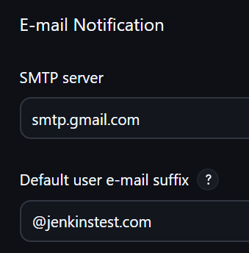
  - 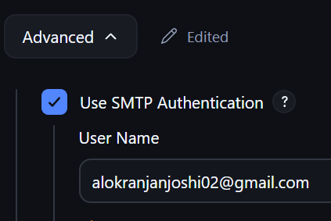
    - You can create app password in by going to your gmail account > manage gmail account > security then search for app passwords
    - 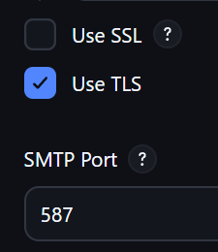 (or) 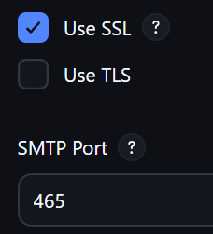
  - Then go to your job and then configuration; under post build action, you need to mention these
    - 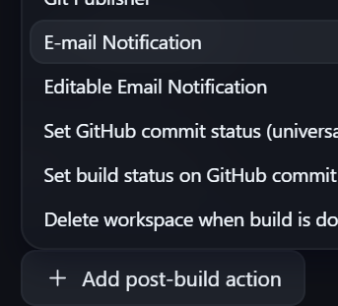(Email Notification
    - 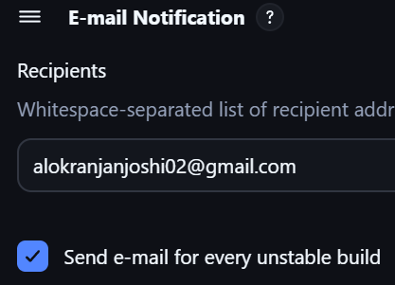
    - If the build will fail, it’ll send a email; and after that if the build passes then it’ll send the email.
    - It’ll not send mail for every passed builds. Just for the failed builds and the first passed build (after that failed builds).

- NOTE ----------------------------------------------------------------------------------------
- The System page is a collector page where each installed plugin can inject its own global configuration section.
- Plugins provide build steps; jobs/pipelines use them.
- -----------------------------------------------------------------------------------------------
- I wanted to do ssh in jenkins to another server, so I installed the plugin named “Publish over SSH” and now, I got one option to add the global configuration for that plugin in the System page.
  - 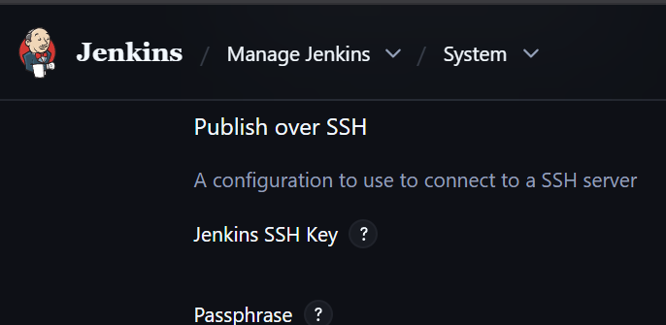
  - Now you’ll get a net option in the build steps inside your job’s configuration
  - 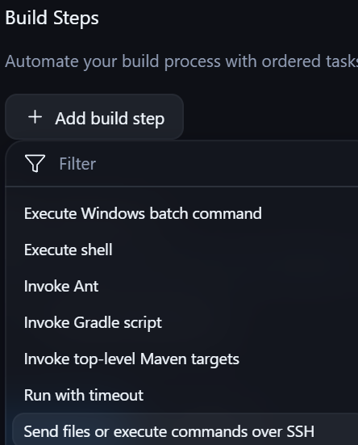
  - This plugin i.e. Publish over SSH can only access the files present in the Job’s workspace and only supports relative path from that workspace.
  - 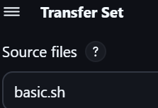 (like this)
  - basic.sh is present inside /var/lib/jenkins/workspace/remote-job

- If you want to give different types of roles to different types of user in Jenkins then install the plugin: Role-based Authorization Strategy
  - After that manage jenkins > security > authorization > select Role-Based Strategy
  - Now you’ll get a new option in the manage jenkins page
    - 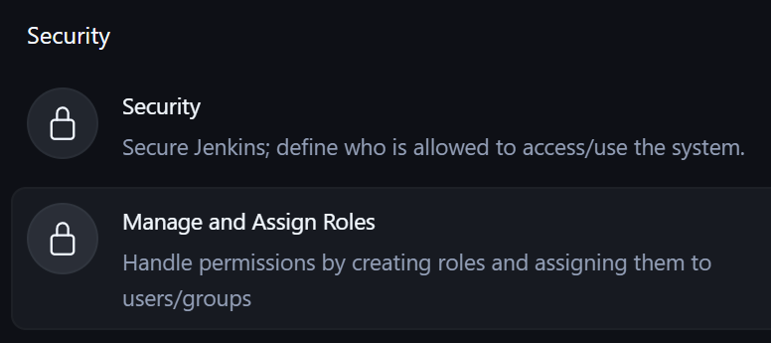
    - Manage and Assign Roles

- You can create global environment variables that can be used by all the jobs
  - Under System page you’ll get the below option
  - 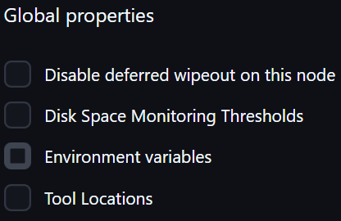
  - Select Environment variables and add your environment variables

- Jenkins can only auto-install tools that are implemented as Jenkins “Tools” by plugins.
  - Anything that is an OS-level dependency or needs root access is OUTSIDE Jenkins’ control.
  - OS level software that requires the following cannot be auto-installed by Jenkins
    - root / sudo
    - Package managers (yum, dnf, apt, apk)
    - Kernel / System access
    - Examples:
      - ❌ Java (system JDK)
      - ❌ Docker Engine
      - ❌ Podman
      - ❌ Git (system git)
      - ❌ curl / wget
      - ❌ unzip / tar
      - ❌ system libraries (glibc, libssl, libstdc++)
      - ❌ systemd services
      - ❌ firewall rules
      - ❌ kernel modules
  - Because, Jenkins run as a non-root user (jenkins user)
  - Here it is being said that it cannot install Java, but Jenkins can install JDK by its own;
  - Whatever Jenkins install, it stores inside the /var/lib/jenkins/tools/ directory and it is only used to run the pipeline.

- NOTE ----------------------------------------------------------------------------------------
- It doesn’t install the tools at the OS level, means when it installs JDK-17 by its own, means it’ll be there inside that tools/ directory and can be used to run the pipeline using that; but you cannot go to the server and run any Java application using that JDK-17.
  - It is only used by Jenkins
- JDK should be installed by you at the beginning, because Jenkins is nothing but a JAR file. To run Jenkins you need to install JDK in your system.
  - After that to run the pipeline, Jenkins will automatically install JDK by its own.
  - Your installed JDK is OS level, Jenkins created JDK is only for pipelines.
- When plugin is installed, Jenkins registers what tools are required for that plugin. And then exposes those tools configuration section in the tools page.
  - Some tools are provided by Jenkins core, ex: JDK, Maven, ..etc.
  - Even if you don’t install plugins for those, it’ll be there in the tools page by default.
  - ------------------------------------------------------------------------------------------

- I installed maven integration plugin and set the maven in the tools page
  - (note: this maven tool is there by default by Jenkins core; not because of maven integration plugin)
  - 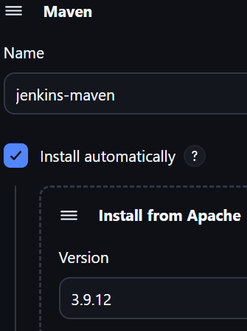
  - Now this name “jenkins-maven” is the alias for maven version 3.9.12
  - Now inside the configuration page of any job, we can use this
    - 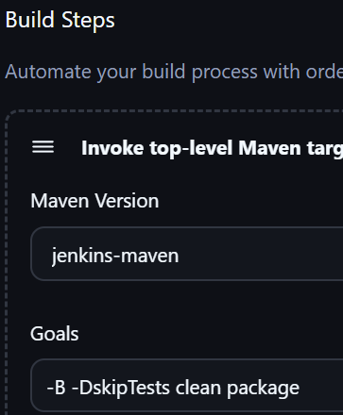
    - Here, don’t need to write mvn for the commands, it’ll be executed with prefix mvn by default.

- You can write groovy syntax in the Pipeline
  - 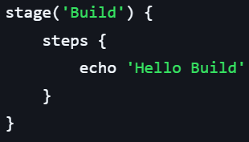
    - Here echo is groovy’s syntax.
  - 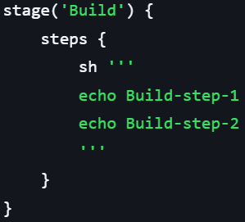
    - Here echo is the bash syntax. As we have written inside sh

- F
- F
- F
- F
- F
- F
- F
- F

  - F

